Use Case UC2: Create Group (By Asma Waseem)
Primary Actor: Administrator
Stakeholders and Interests:
Administrator: Wants to create groups with correct group information and map group to appropriate neighbourhood.
Group members: Want groups to be correctly made and assigned to correct neighbourhoods so they can join the groups and participate in activities.
Team Leaders: Want groups to be correctly made and exist before, so that they can manage groups and organize environmental activities for the group.
Neighbourhood/Community: Wants groups to correctly exist and associated to the neighbourhoods, so that they can join groups of their relative neighbourhood.
System/Organization Management: Wants group information to be properly recorded so members, activities, records, statistics, participation and rankings can be maintained.
Pre Conditions:
- The administrator must be registered and logged into the system.
- The administrator must have permission to create groups.
- The neighbourhood to which group will be associated must already exist in EAMS.
- EAMS database must be available and reliable.
Main success scenario (Basic flow)
- The administrator selects the “Create groups” option.
- The system displays group creation page.
- Administrator enters the group related information including group name and neighborhood. The system automatically generates a unique Group ID for the new group.
- Administrator submits group information.
- System validates group information.
- System creates and saves information of newly created groups in the database.
- System associates’ group with the selected neighbourhood.
- System displays a confirmation message on the screen in case of successful creation.
Alternative Flows:
*a. At any time system fails:
- System can be recovered from any step of scenario.
3a. Group Details missing in database:
- System will not display drop down list to administrator.
- The admin will inform database manager about missing information.
- Information will be added to the database
- Admin repeats step 1 to 3.
3b. Group name already exist:
- System checks whether a group with same name exist in the selected neighbourhood
- System detects duplicate and shows error message to admin.
- Administrator re enters valid group name and continue to step 4
4a. Mandatory Columns are not filled:
- System shows errors to the missing column.
- Administrator enters missing information.
- Admin submits information again and continues from step 6.
Success Guarantee (Post Conditions):
- The new group is successfully created and stored in database.
- The group is associated to the correct neighbourhood.
- The newly created groups are available in EAMS to be joined by people.
- Administrator receives confirmation that group has been created successfully.

Special Requirements:
- Only a user with Administrator role will be allowed to create a group.
- The system will validate the group name and neighbourhood before creating the group and will not create the group and display error message if any information is missing or invalid.
- The system will not allow two groups with same name in the same neighbourhood.
- When invalid or incorrect information is submitted system will display appropriate error message and will not create the group.
- The system must display confirmation of created group or any error message in no more than 5 seconds 90% of the time.
- Group and neighbourhood information will only be accessible to authorized users according to their assigned roles.
- The system must be available when team Administrator creates a group so the group information can be successfully stored in the database.
Technology and data variations list:

- The Administrator will access the EAMS on a web browser on a laptop, computer or smartphone.
- The system uses a database to store group.
- The system uses drop down menus for selecting neighbourhoods.

Frequency of occurrence:
Occasionally. Occurs whenever Administrator wants to add a new group.
Open issues:
- It needs to be decided if administrator can cancel or edit created groups.
- It needs to be decided if a group can be deleted once it is created.
- It needs to be decided if group information can be edited once it is created.
- It needs to be decided how long cancelled, completed and done activities history should be stored in the system’s history.
- Maximum and minimum number of group members need to be decided.
User story 1: As an administrator, I want option to create group by adding group name and neighborhood, so that group can be made available to the people in respective neighborhood. (Priority: high)
Acceptance criteria:
- The group creation page should provide a column to add group name and an option to select available neighborhood.
- The system should automatically generate a unique Group ID when a new group is created.
- The administrator should be able to submit after entering all the information.
- The system should save the details of newly created groups and associate it to respective neighbourhood.
- After the group is created successfully, system should show a confirmation massage.
User story 2: As an Administrator, I want the system to validate group details before creating group, so that duplicate or incomplete groups are not created. (Priority: medium)
Acceptance Criteria:
- The system should require both group name and neighbourhood to crate group.
- The system should display error message if group name or neighbourhood is missing or invalid.
- System should not allow two groups with same name in the same neighbourhood.
- System should create group only if all the required information is correctly provided.

System Sequence Diagram:

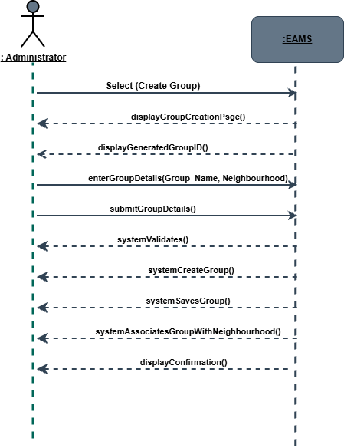

Sequence Diagram:
Use case: create group (by Asma)
